**Download Apache Kafka -->** [**https://www.apache.org/dyn/closer.cgi?path=/kafka/2.7.0/kafka_2.12-2.7.0.tgz**](https://www.apache.org/dyn/closer.cgi?path=/kafka/2.7.0/kafka_2.12-2.7.0.tgz)

**Keep Apache Kafka folder in D:  
1.** **Start the Zookeeper**

Open a command prompt and **start the Zookeeper-**1. Open cmd 🡪 Go to path 🡪 D:\kafka_2.12-2.7.0  
2. D:\kafka_2.12-2.7.0>  
3. Type 🡪 .\bin\windows\zookeeper-server-start.bat .\config\zookeeper.properties  
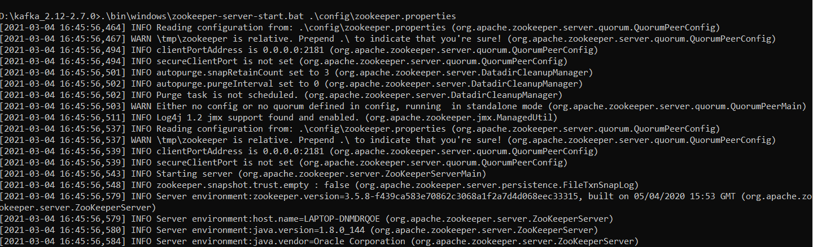

**2.** **Start the Apache Kafka**

Open a new command prompt and **start the Apache Kafka-**1. Open cmd 🡪 Go to path 🡪 D:\kafka_2.12-2.7.0  
2. D:\kafka_2.12-2.7.0>  
3. Type 🡪 .\bin\windows\kafka-server-start.bat .\config\server.properties  
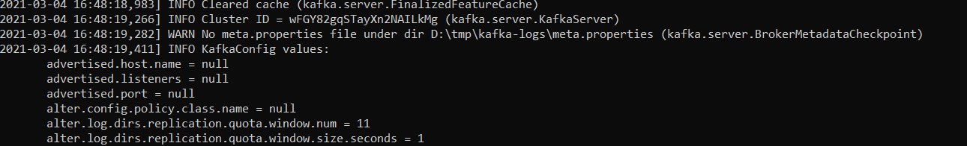

**3.** **create a new topic**

Open a new command prompt and create a topic with **name javainuse-topic**, that has only **one partition & one replica.**1. Open cmd 🡪 Go to path 🡪 D:\kafka_2.12-2.7.0  
2. D:\kafka_2.12-2.7.0>  
3. Type 🡪   
.\bin\windows\kafka-topics.bat --create --zookeeper localhost:2181 --replication-factor 1 --partitions 1 --topic javainuse-topic

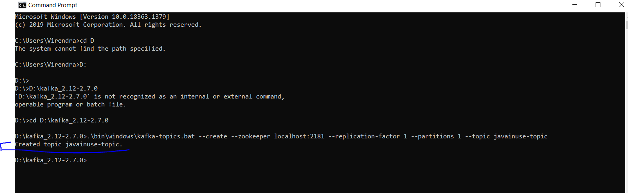

**4. Verify create topic in list**The below command is used to list all the topics to verify the created topic is present in this list1. Open cmd 🡪 Go to path 🡪 D:\kafka_2.12-2.7.0  
2. D:\kafka_2.12-2.7.0>  
3. Type 🡪 .\bin\windows\kafka-topics.bat --list --bootstrap-server localhost:9092

**5.** **create a producer to send message**  
Next Open a new command prompt and **create a producer to send message to the above created javainuse-topic and send a message - Hello World Javainuse to it-**

1. Open cmd 🡪 Go to path 🡪 D:\kafka_2.12-2.7.0  
2. D:\kafka_2.12-2.7.0>  
3. Type 🡪   
.\bin\windows\kafka-console-producer.bat --broker-list localhost:9092 --topic javainuse-topic

Hello World Javainuse

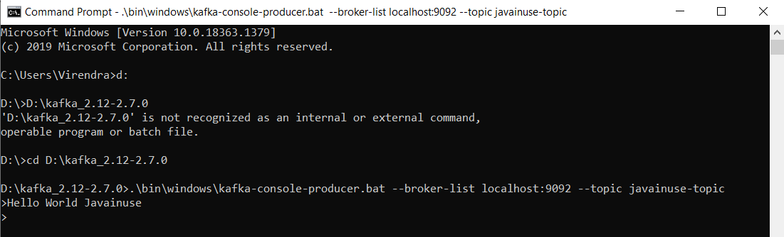

**6. start the consumer which listens to the topic**

Finally Open a new command prompt and **start the consumer which listens to the topic javainuse-topic we just created above**. We will get the message we had sent using the producer.  
  
1. Open cmd 🡪 Go to path 🡪 D:\kafka_2.12-2.7.0  
2. D:\kafka_2.12-2.7.0>  
3. Type 🡪   
.\bin\windows\kafka-console-consumer.bat --bootstrap-server localhost:9092 --topic javainuse-topic --from-beginning

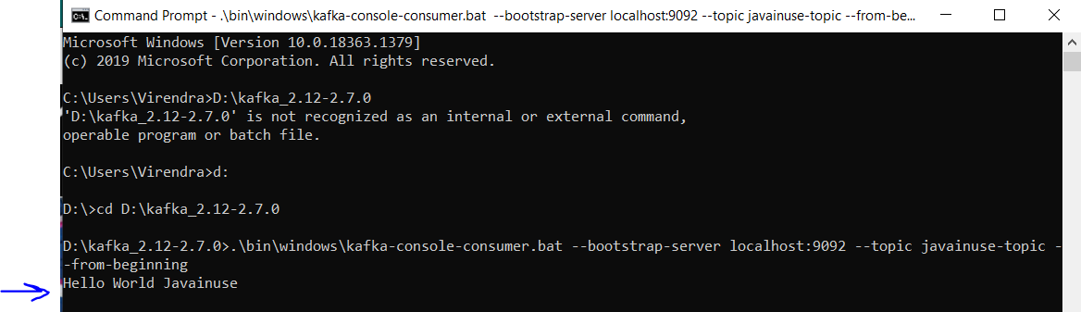  
  
Output will come as 🡪 **Hello World Javainuse**

**7. Shutdown Kafka  
To stop Kafka, we need to run kafka-server-stop.bat script.**  
  
1. Open cmd 🡪 Go to path 🡪 D:\kafka_2.12-2.7.0  
2. D:\kafka_2.12-2.7.0>  
3. Type 🡪 .\bin\windows\kafka-server-stop.bat

**8. Shutdown Zookeeper**  
**To stop Zookeeper, we need to run zookeeper-server-stop.bat script**.  
  
1. Open cmd 🡪 Go to path 🡪 D:\kafka_2.12-2.7.0  
2. D:\kafka_2.12-2.7.0>  
3. Type 🡪 .\bin\windows\zookeeper-server-stop.bat

## **Verify Kafka Installation**

1. Start Zookeeper using above scripts 🡪(1)
2. Start Kafka using above scripts 🡪 (2)
3. Create new topic 🡪 (3)
4. Verify the topic in the list 🡪 (4)
5. Create a producer to send message to topic 🡪 (5)
6. Start the consumer to listen to topic 🡪 (6)

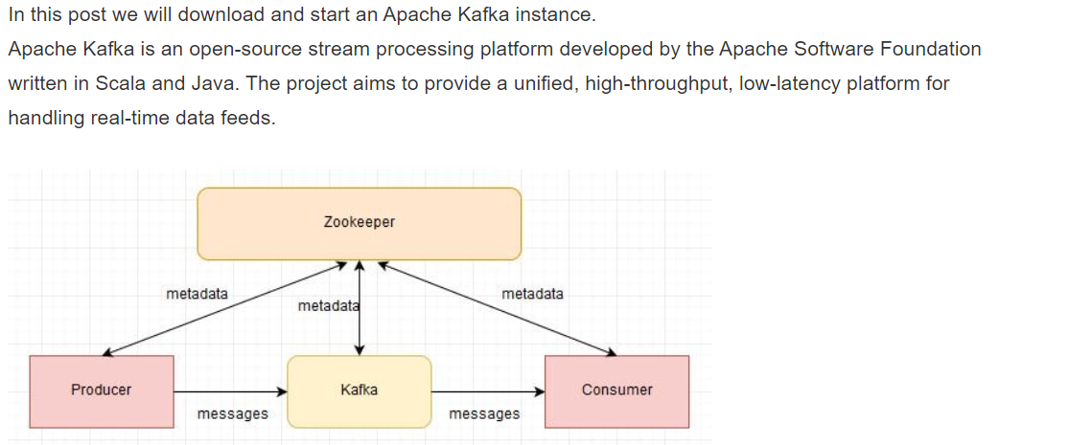

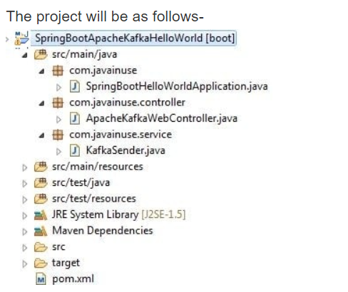

**Once Java coding is done above then follow below steps:**

1. Start Apache Zookeeper (shown above -1 )
2. Start Apache Kafka (shown above -2 )
3. Run the Java Application 🡪 “SpringBootHelloWorldApplication.java”
4. Open Chrome 🡪 <http://localhost:8080//javainuse-kafka/producer?message=test>  
     
   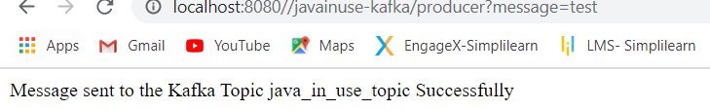
5. Start the consumer listening to the java_in_use_topic- (written in java file)  
   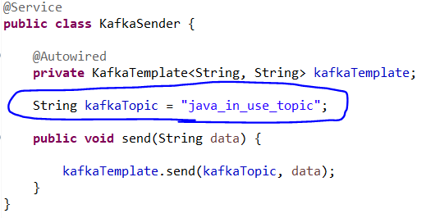  
   Open cmd and follow the step (shown above- 5)

D:\kafka_2.12-2.7.0> .\bin\windows\kafka-console-consumer.bat --bootstrap-server localhost:9092 --topic java_in_use_topic --from-beginning

Once you press enter automatically message will come 🡪 test

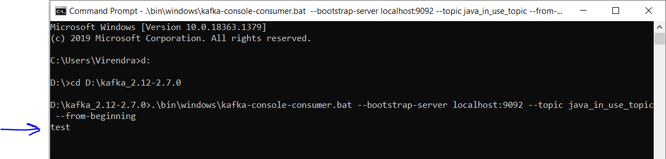

(This will trigger the message to be sent to the java_in_use_topic. We can see in the consumer started the message is recieved.)

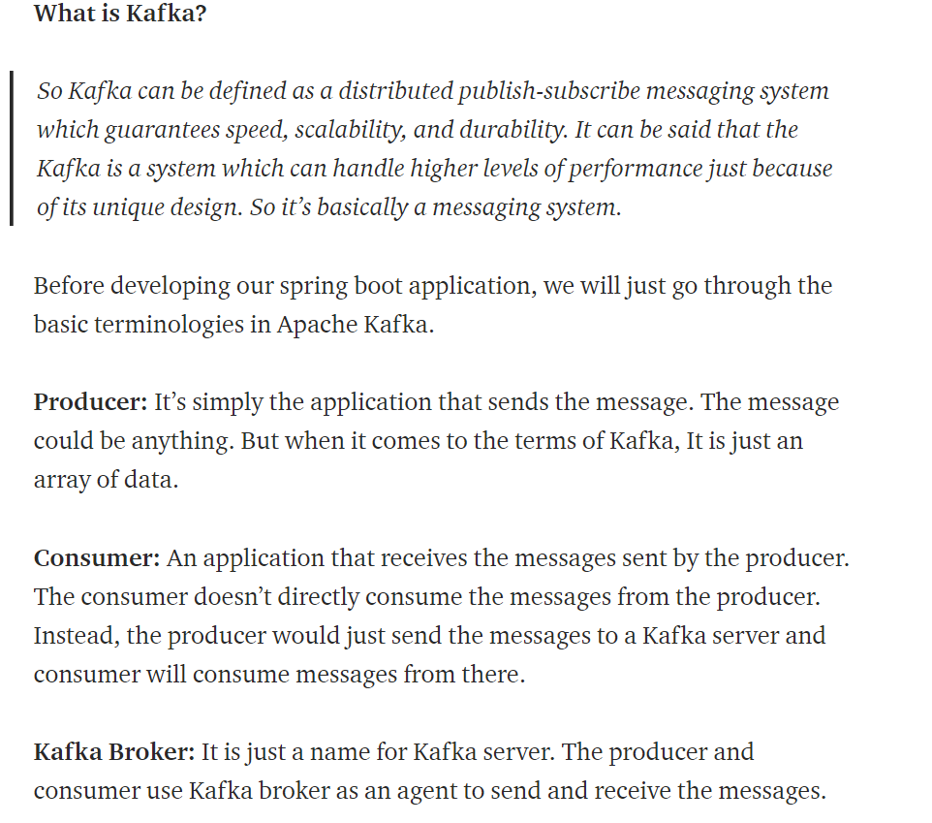  
  
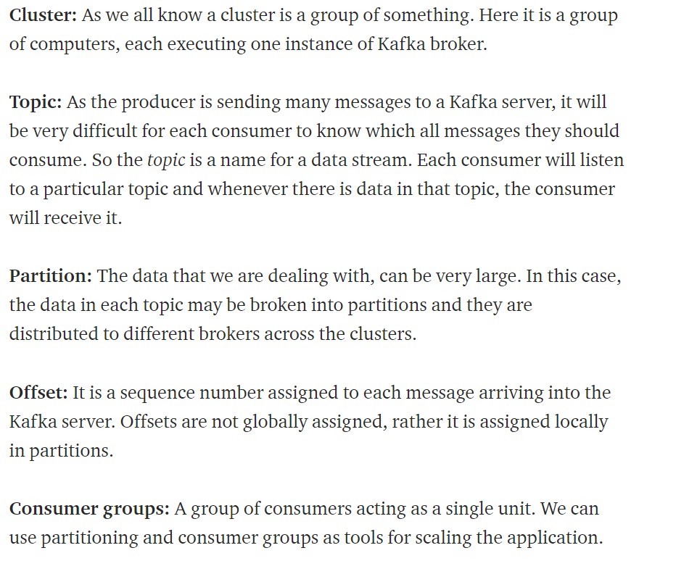

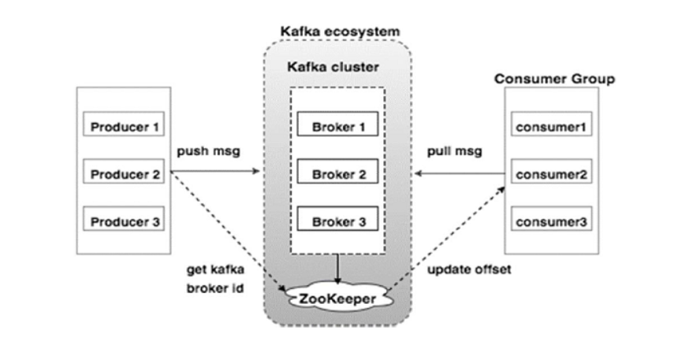  
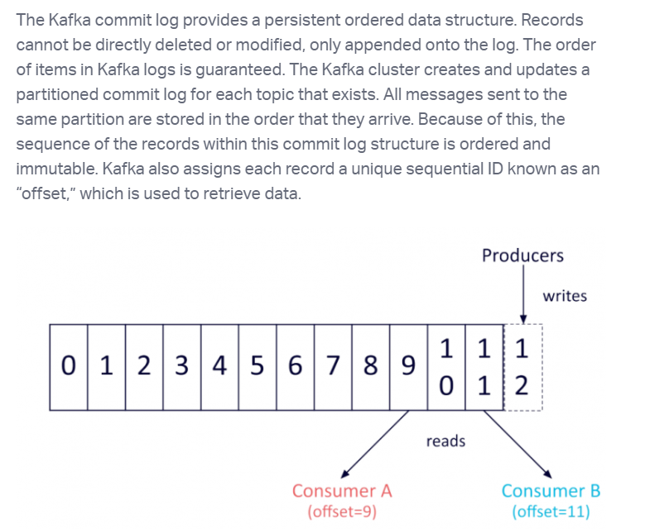

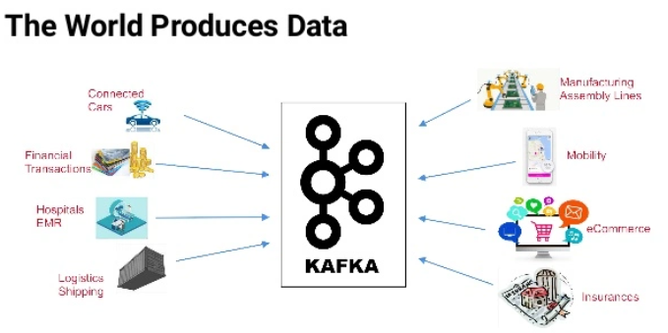

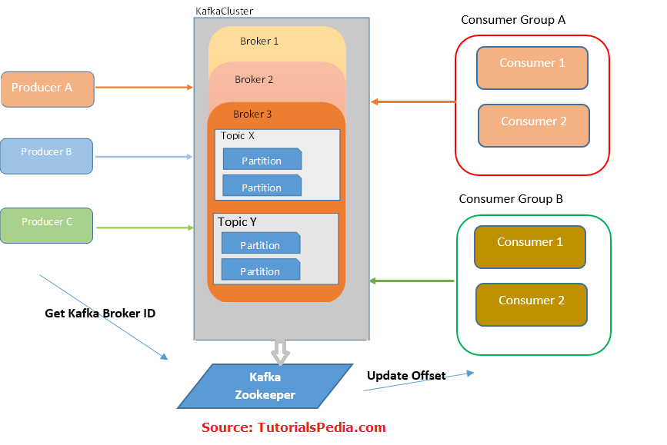

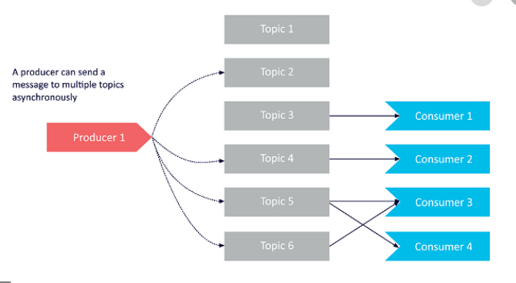

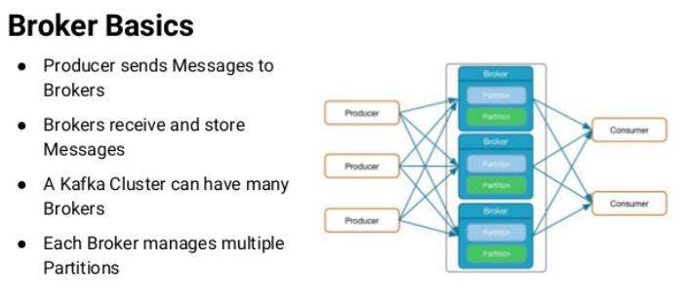

## **Apache Kafka Architecture –**

